WORKSHOP REPORT

March 24th, 2009 in Florence
1. Agenda
(2.00 pm – 5.00 pm)

- Evaluation of Module 2 (Communication)
- Proposals to improve Module 2

2. List of participants

The teachers responsible for the five testing schools:
Carla Favilli (IP Einaudi, Grosseto)
M. Assunta Campanile (ITI-IPSIA Da Vinci, Firenze)
Marco Manzuoli (IP Datini, Prato)
Barbara Degl’Innocenti (IP Enriques, Castelfiorentino)
Daniela Giovannini (ISI Da Vinci, Arcidosso)

The ten testing teachers:
Fiorella Querci - Federica Corradi (IP Einaudi)
Giuliano Fantechi - Monica Santucci (ITI-IPSIA Da Vinci)
Paola Bertini - Paola Fiammelli (IP Datini)
Elisa Chiti - Baragatti Gabbriella (IP Enriques)
Erina De Angelis - Maria Napoleone (ISI Da Vinci - Arcidosso)

Research Team:
Mauro Di Grazia (CIPAT)
Giuseppe Italiano (CIPAT)
Anna Maria Giagnoni
Lucia Fiorentini

3. Photo taken at CIPAT offices, Piazza S.Ambrogio, Florence

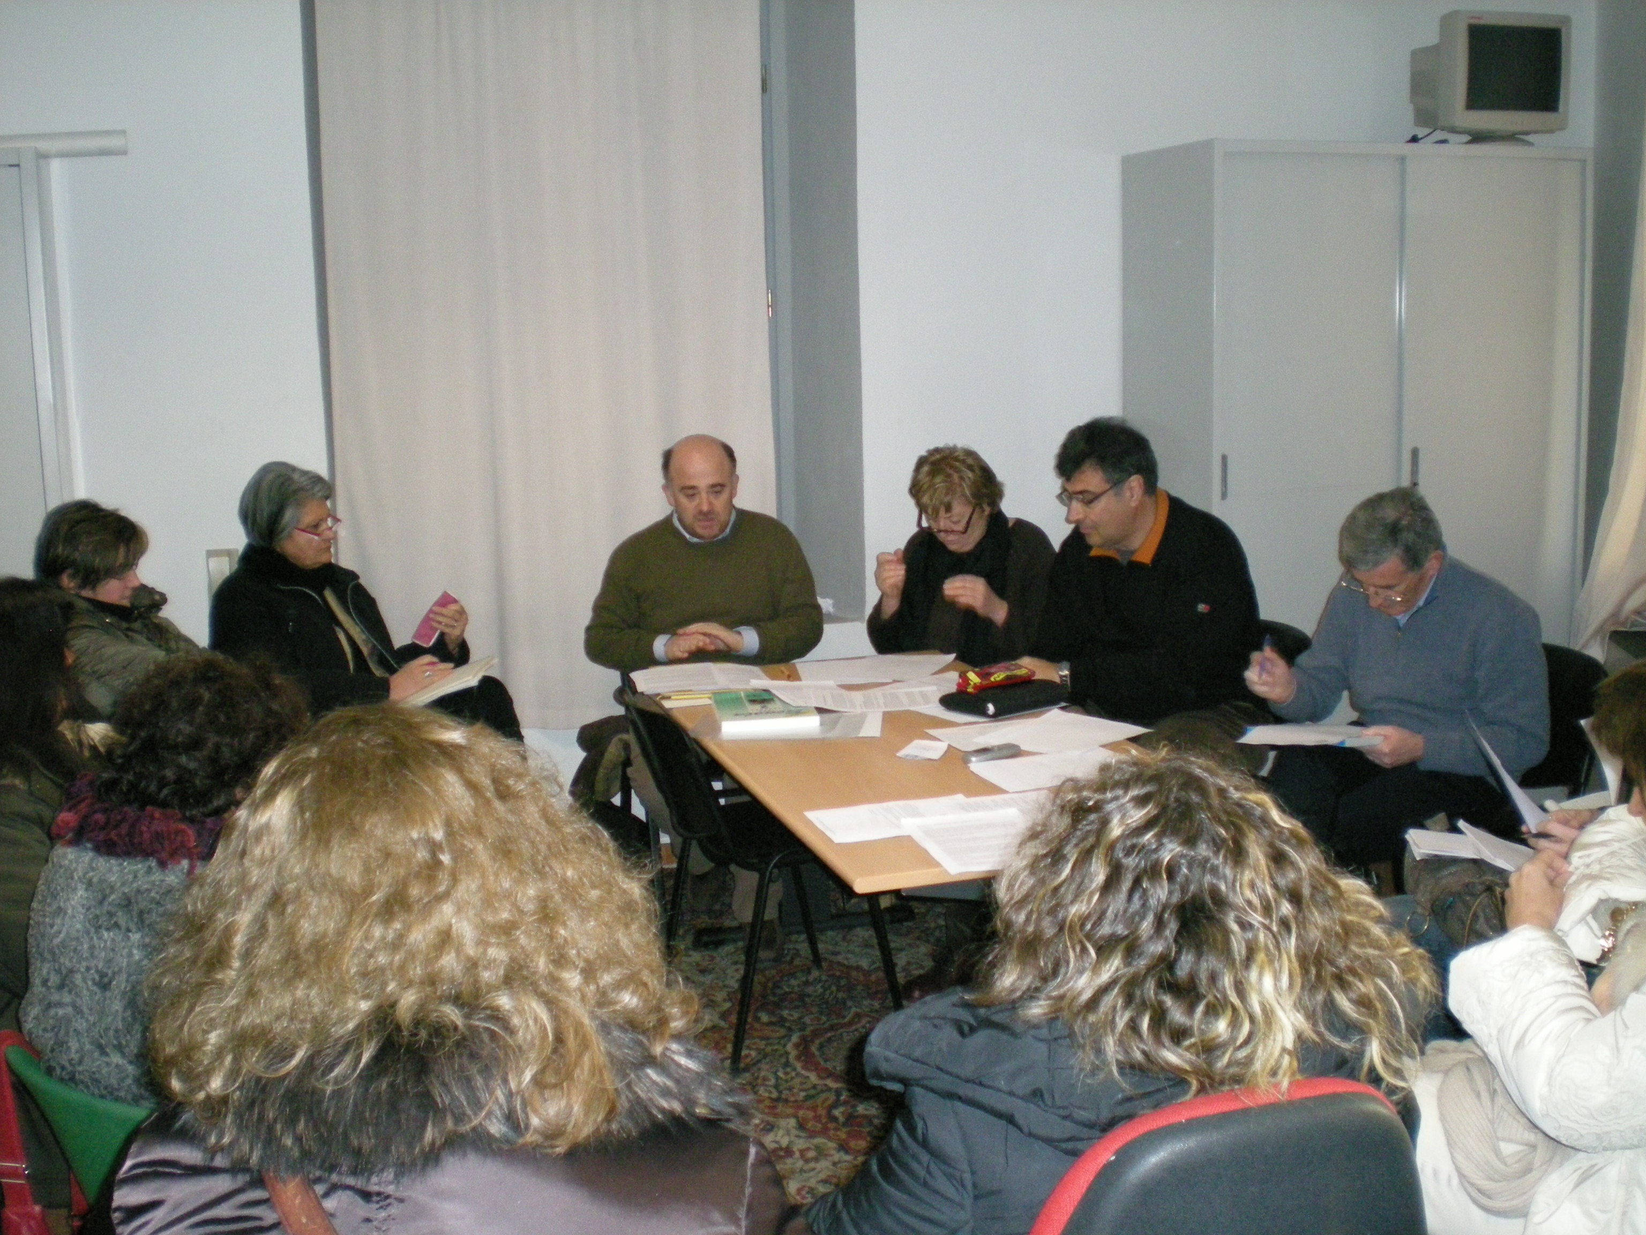
4. Workshop minutes

a) Meetings at the testing schools
In each testing school, meetings were held previously to allow an easier management of the workshop. The two testing teachers together with the member/s of the regional research group read the module, as well as the links, on line. The minutes of these meetings are at CIPAT’s.

b) The workshop started with the presentation by the teachers responsible for each school of the agreed comments and of any different opinion.
The single points were discussed in detail following the SWOT method and a very positive evaluation of the module was agreed, even though some paragraphs appeared to be rather long with the risk that future trainees may miss the main points.
All the teachers were present and each participant had repeated opportunities to express their opinions. At the end of the long debate the following analysis was agreed:

STRENGTHS:
The module offers a clear picture of the main principles of communication psychology at different levels ( in classroom and outside) and with different receivers (students, truants, parents) with very useful suggestions.
The teachers appreciated the very large range of practical tools aiming at the solution of problems (questionnaires, grids to evaluate and monitor activities, good practices, relevant links).
The module gives precise, well structured indications of how to approach and manage conflicts.
The teachers found the tools to practise self-analysis quite helpful to recognize and properly manage the different aspects of their own emotional problems.

WEAKNESSES:
The variety of information sometimes tends to become too much detailed, particularly in Chapter 3 and 4, and it may lead teachers to miss priorities or feel confused.
OPPORTUNITIES:
The materials appear to be particularly useful to train all the staff who have coordinating tasks, a kind of training too often forgotten in our schools.
It can be used as a reference book where teachers can select the tools they need as occasion may require.

THREATS:
Indications and instructions are so detailed that we feel there is the risk that teachers will use them without the flexibility the actual situations may require.

5. Possible improvements
We would suggest to summarise the longest paragraphs in order to highlight the main points.

The workshop finished at 5.15.

